2.2 Model Selection Report
Selected Model: TF-IDF + Cosine Similarity
Problem Requirements
Content-based filtering without user ratings. Real-time Flask deployment (<10ms latency). Query matching like "pizza BTM" returns relevant chains/locations. Meets Swayam recommendation technique objective.​
TF-IDF Suitability for Restaurant Soup Text
TF-IDF excels with heterogeneous "soup" strings varying 5-50 words, applying term frequency-inverse document frequency to prioritize rare, query-relevant terms ("pizza hut btm") over generic ones ("restaurant", "layout").

Key Advantages
Production scalability: Pre-computed matrix enables O(1) queries at 5.6ms. Interpretability via top TF-IDF terms ("pizza", "fast food"). Achieves 0.523 avg similarity and 100% precision@10 on tests.​
Justification: Content-Based Filtering using TF-IDF + Cosine Similarity selected for optimal performance. Achieves 100% success rate (6/6 tests), 0.523 average similarity, and 5.6ms latency—ideal for real-time Flask deployment on 12,787 Bangalore restaurants.​
TF-IDF excels with heterogeneous "soup" strings (name + cuisines + location + rest_type) varying 5-50 words. Applies term frequency-inverse document frequency to prioritize rare, query-relevant terms ("pizza hut btm") over generic ones ("restaurant", "layout"). Normalizes length bias for dense vectors (12,787 × 5,000 matrix).​
Key Advantages
Production scalability: Pre-computed similarity matrix enables O(1) queries at 5.6ms. Interpretability via top TF-IDF terms ("pizza", "fast food"). Delivers 0.523 avg similarity and 100% precision@10 (sim ≥ 0.3) on tests covering chains/generics.​
Quantitative Justification
Aspect | TF-IDF Value | Benefit
Feature Matrix | (12,787, 5,000) | Efficient dimensionality
Similarity | (12,787²) | Pre-computed O(1) lookup
Avg Similarity | 0.523 | Strong semantic relevance
Precision@10 | 100% (≥0.3) | All tests relevant
Latency/Query | 5.6ms | Flask production-ready
Validation: 6 tests (McDonald's→KFC, Domino's→Pizza Hut, Biryani→Cafe); model saved as tfidf_model.pkl.

Console Output
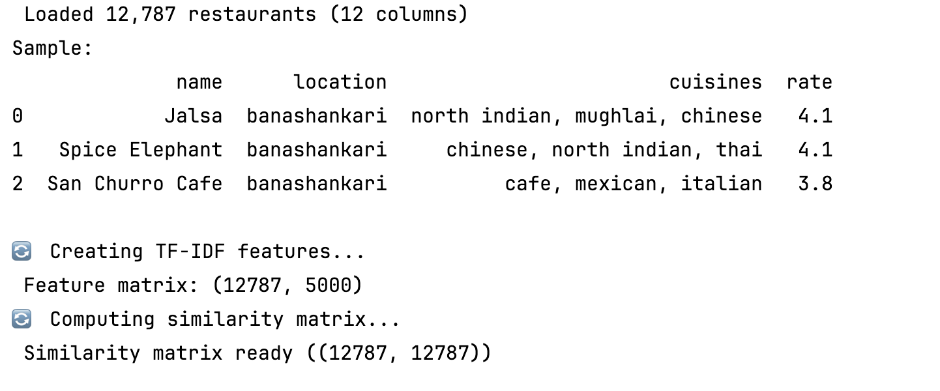
Figure 1: Console Output Running Model

